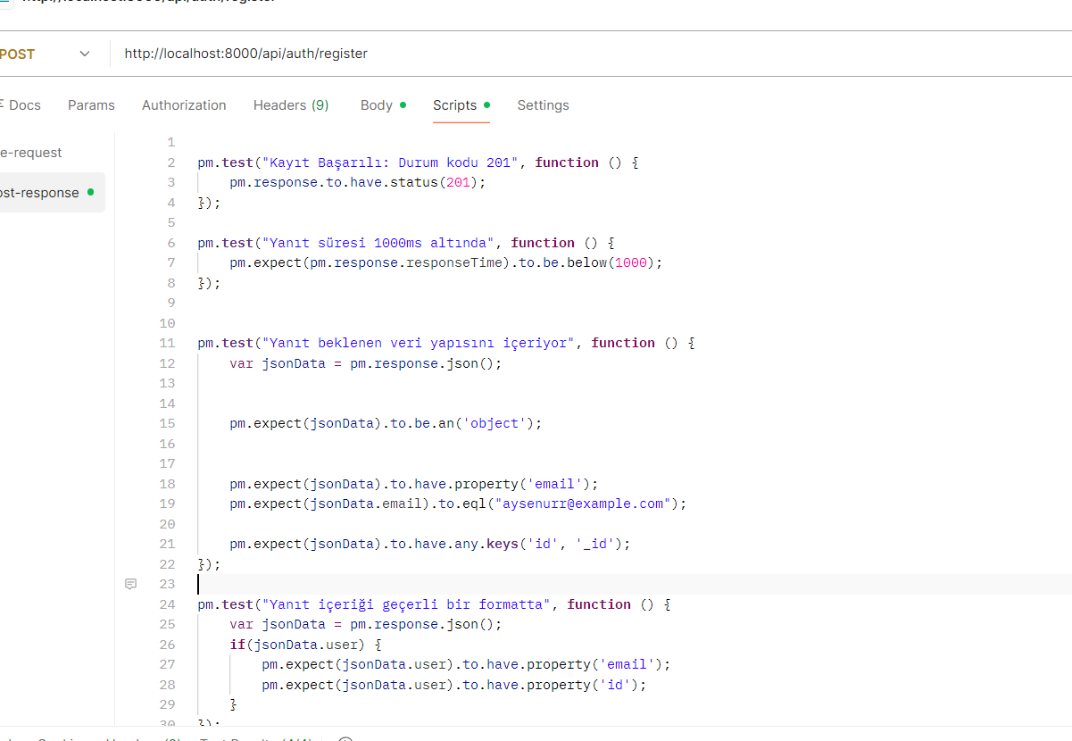
8.1 code for backend API endpoint tests
The visual presented in this section illustrates the automation scripts developed within the Postman environment to verify the reliability and data integrity of the backend API endpoits:
HTTP Status Code Validation: The script specifically monitors the /api/auth/register endpoint to ensure it returns an HTTP 201 (Created) status, confirming that a new user resource has been successfully generated in the database.
Performance Benchmarking: To ensure high-quality user experience and server efficiency, a performance constraint is implemented to verify that the response latency remains below 1000ms.
Data Structure and Integrity Checks: The test programmatically validates that the response is in JSON format and contains the necessary keys, such as the email field and the database-assigned unique identifiers (id or _id).
Logical Consistency: By comparing the returned email with the initial request data, the script guarantees that the API maintains strict data consistency across the registration process.

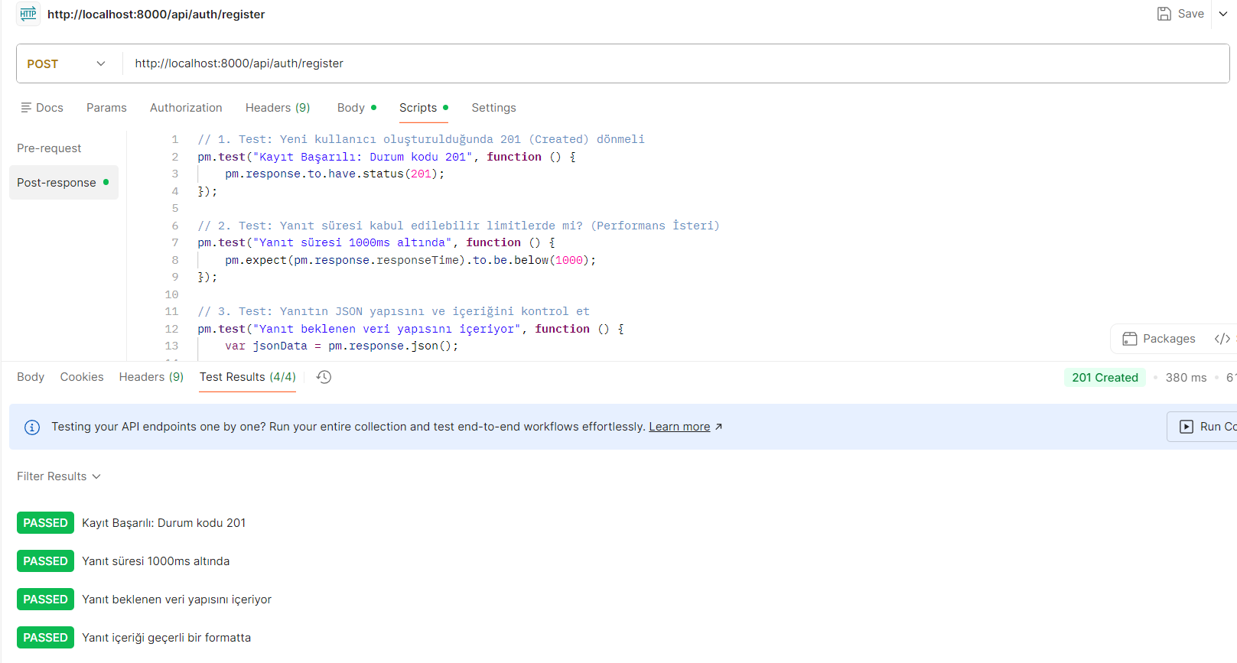
8.2 test results
This visual provides concrete evidence that the registration API endpoint has successfully passed all functional and technical validation criteria:
Comprehensive Pass Rate: All four designated test scenarios achieved a 100% success rate (4/4 PASSED), demonstrating the robustness of the backend logic.
End-to-End Integration Confirmation: These results confirm the seamless integration between the frontend data requirements, the backend logic, and the MongoDB Atlas cloud database.
Latency Analysis: The API demonstrated an efficient response time of 380 ms, which proves the system's ability to handle requests with high performance and minimal delay.
Functional Reliability: The successful test execution serves as a formal verification that the user registration workflow fully complies with the project’s technical specifications and business rules.

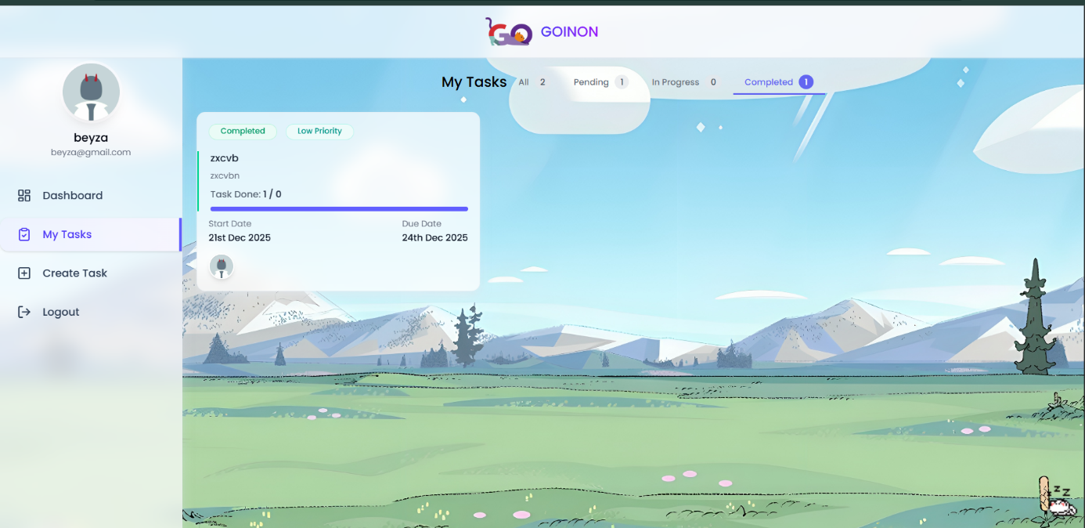

8.3 visual showing completed tasks on the interface
This visual demonstrates the "Completed" tasks view within the application's task management section. The interface effectively filters and displays finished work, highlighting each item with a "Completed" status badge. Users can verify their progress through clear timeline indicators, including start and due dates, ensuring all project milestones are documented.
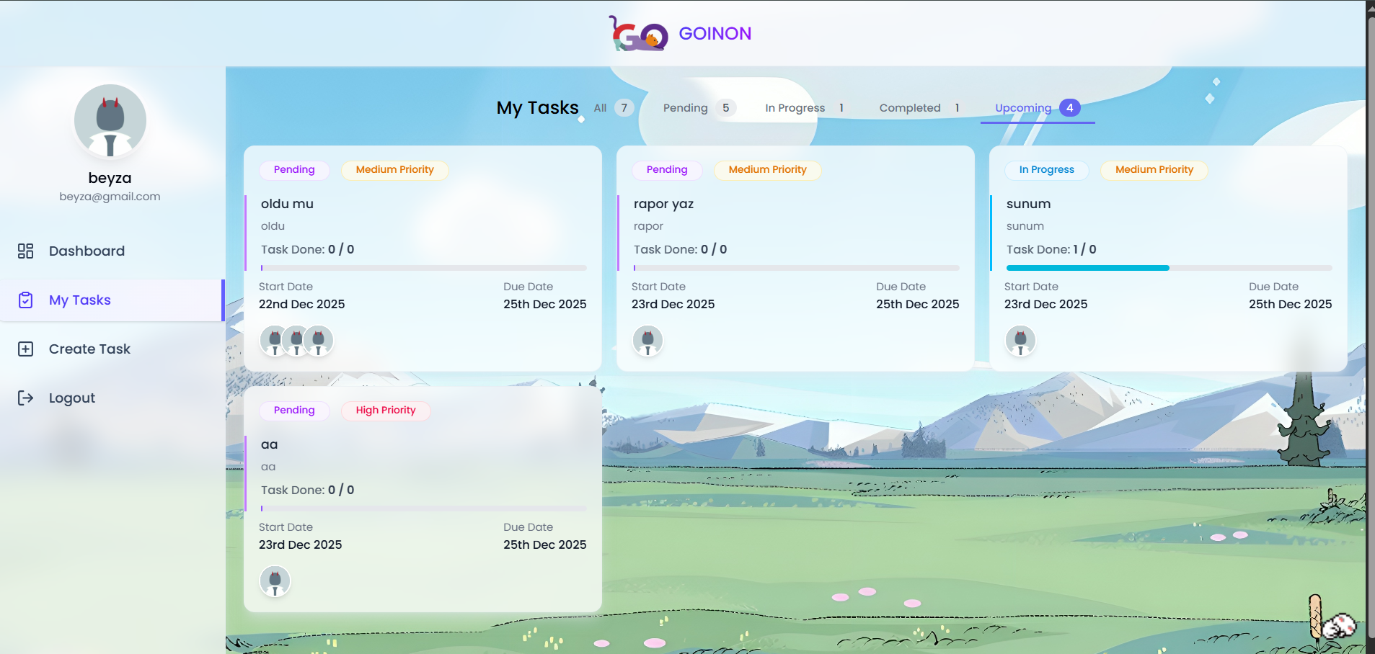8.4 visual showing approaching deadlines
The task management interface provides a dedicated timeline for each entry, highlighting the "Due Date" to ensure effective time management. As illustrated, the system tracks imminent deadlines—such as the "Yazılım Geliştirme Sunumu" due on December 24th, 2025—allowing users to prioritize tasks that are close to their expiration. This visual tracking mechanism is essential for meeting project milestones without delays.


8.5.1 visual showing interface filtering feature
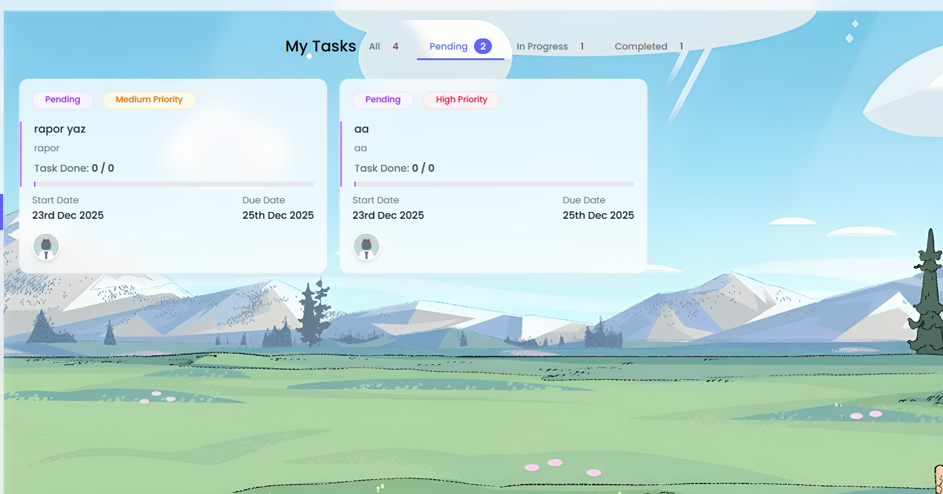
8.5.2 visual showing interface filtering feature
The application provides a robust status-based filtering system located at the top of the task dashboard. Users can seamlessly switch between "All", "Pending", "In Progress", and "Completed" views. This real-time filtering mechanism ensures that users can manage high volumes of tasks by isolating them according to their current execution phase.

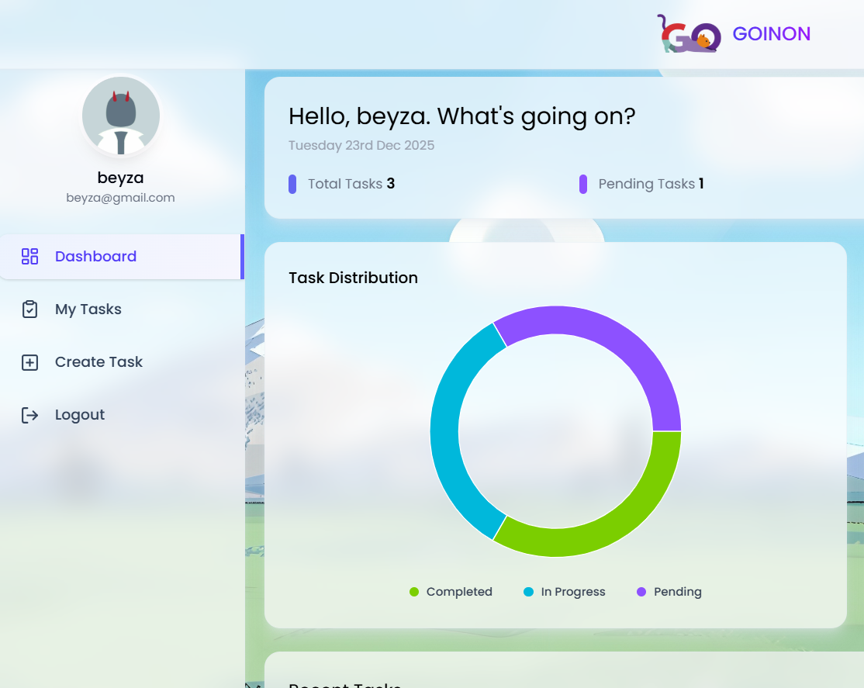
8.6 visual showing task distribution
The Dashboard provides a comprehensive overview of task distribution through an interactive donut chart. It categorizes all tasks into three primary statuses: "Completed", "In Progress", and "Pending". This high-level summary allows users to instantly track project progress, showing at a glance that the majority of work is currently "In Progress" or "Pending".

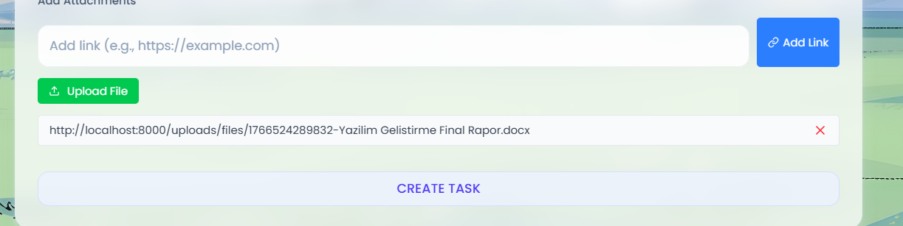
8.7 visual showing task-based file feature
The application features a dedicated "Add Attachments" section within the task creation and management interface. This tool allows users to link external documents, files, and resources directly to a specific task using the "Add File Link" input. By centralizing all relevant materials, the system enhances documentation efficiency and ensures that team members have immediate access to necessary project assets during execution.

